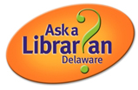

Even if the library  
 building is closed,

we’re always open online!

*Ask a Librarian Delaware*

*is a 247 library chat service*

*and is part of a cooperative of libraries*

Use your library’s website or go to:

**lib.de.us/askalibrarian**

anytime!